









Mona
Abraham
1. Look at the family tree and complete the sentences:
1. Marge is Bart’s …………
2. Mona is Lisa’s ………..
3. Abraham is Herb’s …………
4. Homer is Herb’s………….
5. Herb is Maggie’s ………..
6. Lisa and Maggie are Bart’s………..
7. Abraham is Lisa’s………..



Homer
Marge
Herb

Maggie
Bart
Lisa
5. Match the questions to the answers:
1…..What’s his name?
2…...Where’s he from?
3…...How old is he?
4…… Has he got any sisters?
5….. What’s he like?

2. Fill with can or can’t:
1. …….. Andrew play football?
Yes, he……..
2. …….. Mary cook well?
No, she ….
3. ………Kate and Leo speak English?
Yes, they………
4. ………Tony climb trees?
No, he………..

a. He’s eleven.
b. Sam.
c. He’s from Britain.
d. Yes, he has.
e. He’s very naughty.

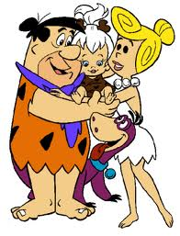
6. Write the opposites:
slim –
big –
short –
quite –

3. Circle the correct answer:
1. This is my/me family.
2. Look at she/her! She is very nice!
3. Mrs. Smith is we/our English teacher.
4. They/there are best friends.
5. Can your/you swim?

7. Make sentences using imperatives:
1. stand up (x) _____________________
2. go home (v) _____________________
3. take my books (x) ________________
4. sit down (v) _____________________
5. be noisy (x) _____________________

4. Match:
as strong
as gentle
as quite
as busy
as stubborn
as cool

as a mule
as a mouse
as a cucumber
as a bee
as an ox
as a lamb

