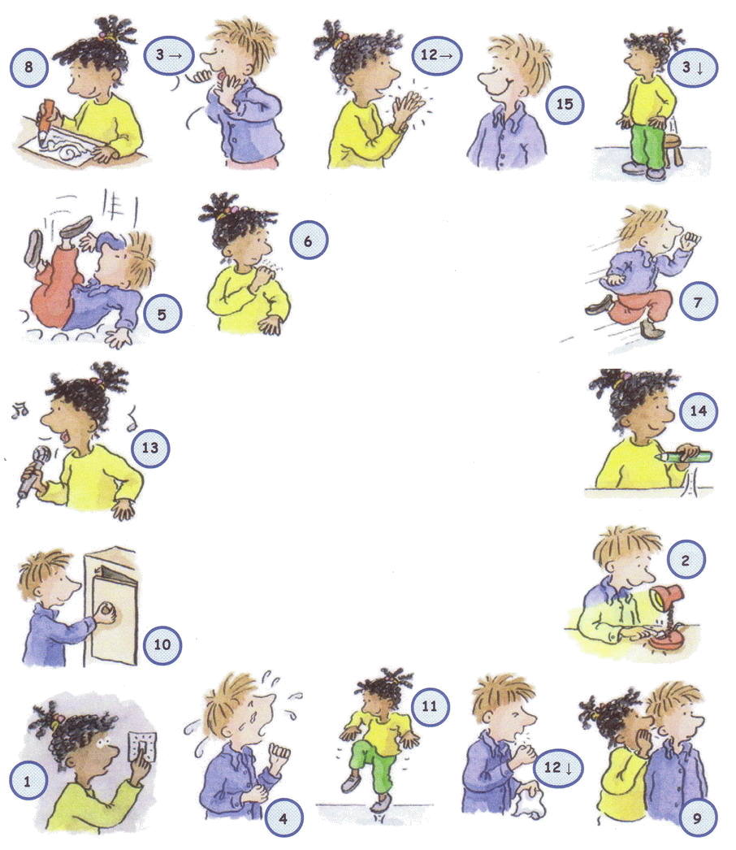
Match the verbs with the pictures and write them in the crossword.
Action Verbs Crossword (2)

clapfallrunsmilewhisper
coughhopscratchstand up
cryopenshoutturn off
drawpick upsingturn on

ANSWER KEY

