Открытый урок «Рождество» в 7 «А» классе,
проведен 24 декабря 2013 года
Целью представленного материала является формирование комплекса лингвострановедческих знаний о национально-культурных особенностях Великобритании. Обычаи и традиции того или иного народа - это прежде всего отражение его истории. Знакомство с ними позволяет лучше понять культуру страны изучаемого языка. Авторская презентация представляет собой своеобразный рассказ о праздновании Рождества в Англии. Такие аспекты праздника, как рождественский венок, пудинг, рождественская открытка, раскрыты через историю их возникновения в культуре этой страны. Многие слайды презентации содержат традиционные для этого праздника английские стихи. Первый слайд сопровождается песней I Wish You A Merry Christmas в исполнении Фрэнка Синатры. К презентации прилагается текстовый файл на английском языке. В заключительной части занятия учащимся предлагается ответить на вопросы о праздновании Рождества.

Ход занятия

1. Организационный момент.
Слайд 1. Название темы занятия. Звучит песня I Wish You A Merry Christmas.

2. Изучение нового материала.
Преподаватель представляет учеников, которые познакомят остальных учащихся с традициями празднования Рождества в этой стране.
Слайд 2. Xmas comes on the 25th of December. Due to Queen Victoria and her husband Prince Albert the United Kingdom started celebrating what we know as “traditional British Christmas”. Before Queen Victoria British Xmas was based on old pagan traditions and was mainly for adults.
Слайд 3. CHRISTMAS TREE. They say the first Xmas tree appeared in Germany in 1521. And it was Prince Albert who brought it to Britain. In 1841 Queen Victoria and Prince Albert had a lighted tree at Windsor Castle. The event was widely reported in newspapers and magazines. It helped to make the custom better known. The royal trees at Windsor made Xmas Tree fashionable. Today an enormous Xmas tree stands in Trafalgar Square. It is a gift from the people of Norway, Every winter since 1947 they cut down a tree for London. When the tree arrives to Great Britain police escort it to Trafalgar Square. It is usually fifty feet high. It stands in the Square from mid-December, when the Ambassador of Norway switches on the lights. Carols are sung around it every evening until Christmas.
Слайд 4. A Garland of greenery which hung from the middle of the ceiling in the main living-room was shaped like a crown and adorned with candles, red apples, and rosettes of colored paper and ornaments of various kinds. These lovely garlands are still to be seen in some English homes, either as an ornamental accompaniment to the Xmas Tree or instead of it.
Слайд 5. The central decoration at home still remains the Xmas tree. It holds great magic for all of us. Usually the tree drops its needles within a few days of being cut. Despite this we are fond of it: its aromatic scent always transports us back to our childhood.
Слайд 6. CHRISTMAS DECORATION. In old times Xmas trees were decorated with apples, toffees and gingerbread. German glass-makers may have been the first to make glass baubles .The so familiar baubles only became available in Britain after 1870. They were from Bohemia where people believed that baubles protected them from evil eye.
Слайд 7. CHRISTMAS CANDLES. Each Xmas people lit candles to memorize the star that was shining when Christ child was born.
Слайд 8. CHRISTMAS WREATH can be on the door or wall. It is evergreen decoration with candles. It is called an Advent Crown. Advent means “coming”. It begins on the 1st of December. Advent Crown came from Germany. The wreath of evergreen may be hung from the ceiling and decorated with four candles. One of these candles is lit on each of the Sundays up to Christmas, until on the fourth Sunday they are all lit.
Слайд 9. CHRISTMAS GREENARY – holly, ivy and mistletoe are considered to be magic. Unlike most plants they are green and bear fruit in winter. So they are regarded as symbols of life.
Слайд 10. Poinsettia is the Xmas symbol too. A lot of pots with this plant are bought at Xmas time; they can be red, yellow and pink colors.
Слайд 11. CHRISTMAS CAROLS .The first carols came from France. Xmas carols are religious songs and tell the story of Christmas. There is also a custom of singing Xmas carols from door to door. The most famous carol is “Silent Night.”
Silent Night, Holy Night!
All is calm, all is bright.
Round the Virgin Mother and Child.
Holy infant so tender and mind,
Sleep in heavenly peace,
Sleep in heavenly peace.
Слайд 12. FATHER CHRISTMAS was known in England in the 15th century. He was named in a carol of that period of time “Hail, Father Christmas, hail to you.” According to the legend Father Christmas is a very old man, who comes from the Far North with the gifts in a sleigh drawn by reindeer. He comes by night in the houses unseen and unheard. At the beginning of the 19th century “Coca-Cola” dressed Father Xmas in their company colors – red and white to advertise their product. And the modern image remains.
Слайд 13. CHRISTMAS PUDDING with its breathtaking aromas is round and dark-colored made with dried fruit and a lot of spice. It is said puddings should be prepared with 13 ingredients to represent Christ and His Disciples. Traditionally, it’s lucky to help make the pudding – so every member of the family takes turn to stir the pudding and make a wish. But to preserve good luck, the pudding should be stirred clockwise and with a wooden spoon. Putting a silver coin in the pudding is another age-old custom that is said to bring wealth, health and happiness to the lucky person who finds it. Xmas pudding is decorated with a small branch of holly on the top.
Слайд 14. CHRISTMAS PRESENTS. The giving of presents at Christmas time has a long pre-Christian ancestry. Before Christianity was known in the world, gifts of various kinds used to be exchanged at some of the pagan religious festivals of midwinter. Children in Britain look to Father Xmas for their gifts on Xmas Eve.
The legend says that Father Xmas once dropped some gold coins down the chimney at midnight. The coins would have fallen through the ash gate and been lost if they had not landed in a stocking that had been hung out to dry. Since that time children put their stockings on the fireplace in hope of finding them filled with gifts.
Слайд 15. CHRISTMAS CARDS. Queen Victoria may have also started the great British tradition of giving Xmas cards. She wrote a card for each member of the Royal Family. The cards were hung on a big Christmas tree. Nowadays, almost every British person gives or sends a Christmas card to each member of their family, close friends, colleagues, neighbors, distant relatives, a favorite pet… The list is endless. You can of course receive Xmas card by e-mail.
Слайд 16. Christmas card has got more value than a telephone call with the best wishes for Christmas. Your Xmas card will be put on the mantelpiece and will stand till the middle of January. It’s not difficult to write the Xmas cards today. Everything is ready, all is written, you have only to add some warm wards and put your name.
Слайд 17, 18, 19.
Учащимся предлагается ответить на следующие вопросы для контроля понимания темы.
ANSWER THE QUESTIONS.
- When does Xmas come? On the 25th of December
- Who started “traditional British Christmas”? Queen Victoria
- Where did the first Xmas tree appear? In Germany
- Who brought it to Britain? Prince Albert
- Where does the Xmas tree stand nowadays? In Trafalgar Square
- What country sends it to Britain every year? Norway
- Who switches on the lights on the Xmas tree which stands in Trafalgar Square? The Ambassador of Norway
- How was the Xmas tree originally decorated? With apples, toffees and gingerbread
- Who was the first to make glass baubles? German glass-blowers
- What is an “Advent Crown”? A wreath of evergreens decorated with candles
- What the word “Advent” means? It means “coming”
- Why are holly, ivy and mistletoe considered to be magic? They are green and bear fruit in winter
- What another Xmas plant is the symbol of Xmas? Poinsettia
- Where did the first carol come from? From France
- What is the most famous carol in the UK? Silent Night
- Who dressed Father Christmas in a red and white costume? “Coca-Cola” company
- What is the traditional decoration for Xmas pudding? A small branch of holly on the top
- What can you put into the Xmas pudding? A coin, a ring
- Where do British children put their stockings on Xmas Eve? On the fireplace
- Who started a great tradition of giving Xmas cards? Queen Victoria

3. Подведение итогов.
ЛИТЕРАТУРА
- 1.Великобритания. Лингвострановедческий словарь.М.1980.
- Customs, Tradition and Festivals of Great Britain. T. Khimunina. M. 1984.
- British Festivals. Бурова И. И. СПб. 1996.
- Speak Out. № 64.
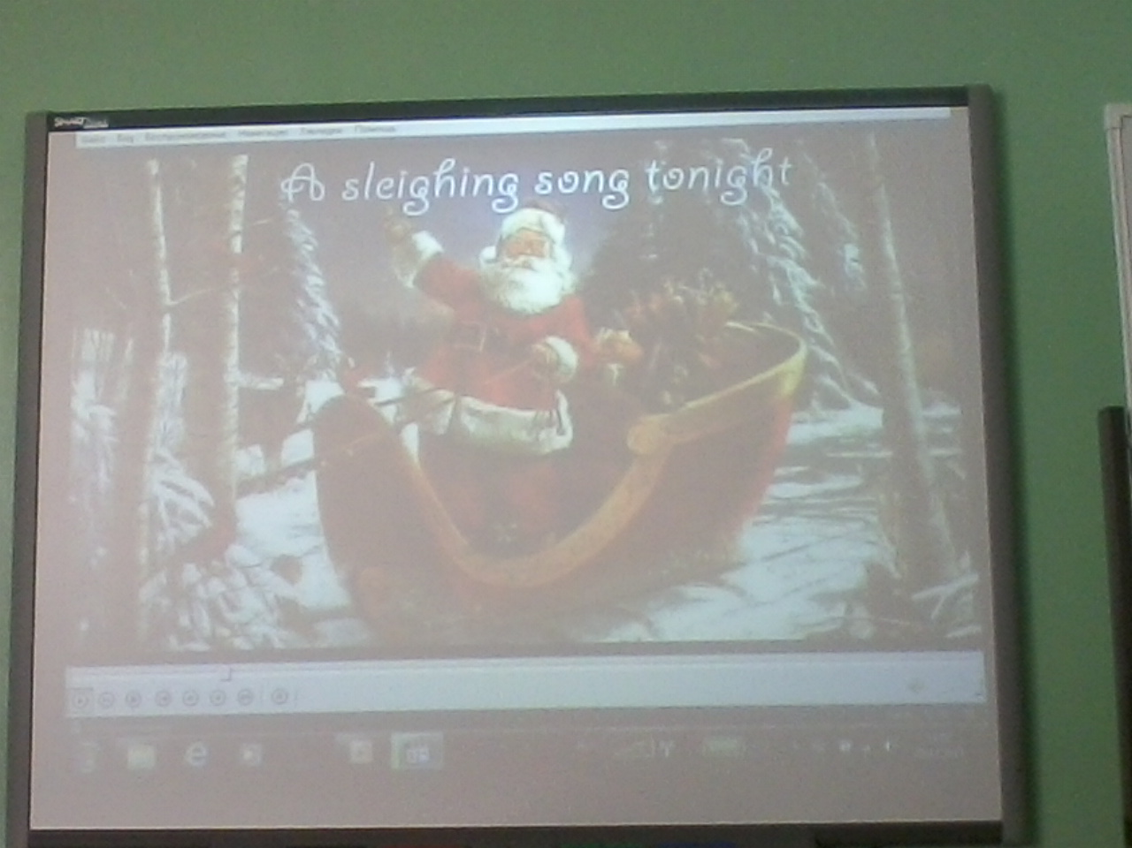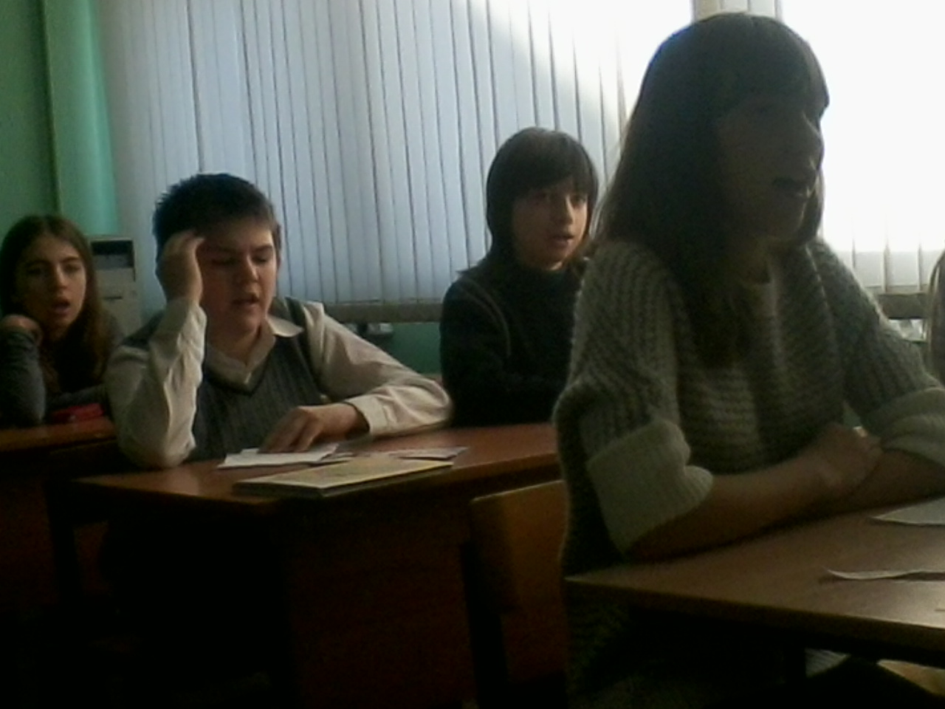
Ученики поют песню «I Wish You A Merry Christmas.»

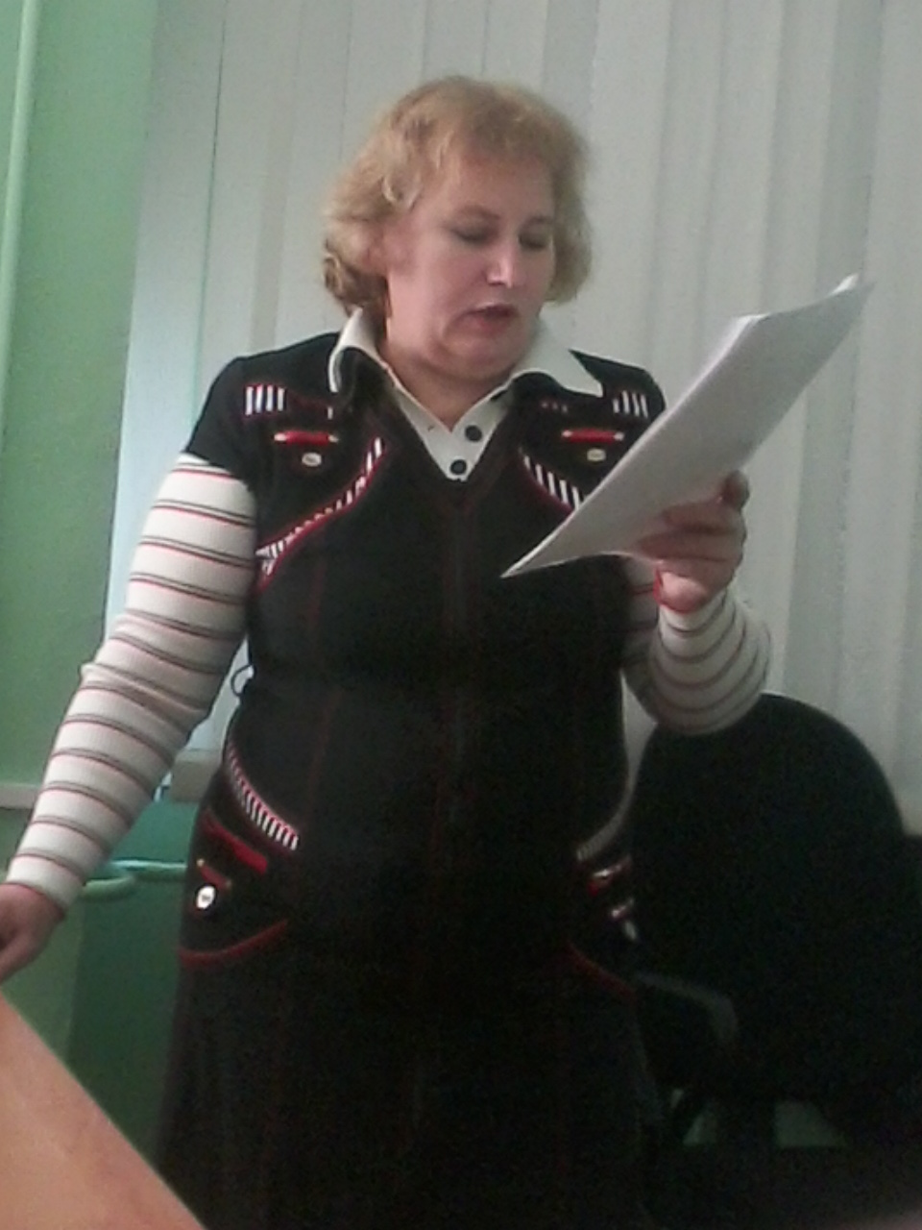
Учитель английского языка Петруненко Ольга Александровна
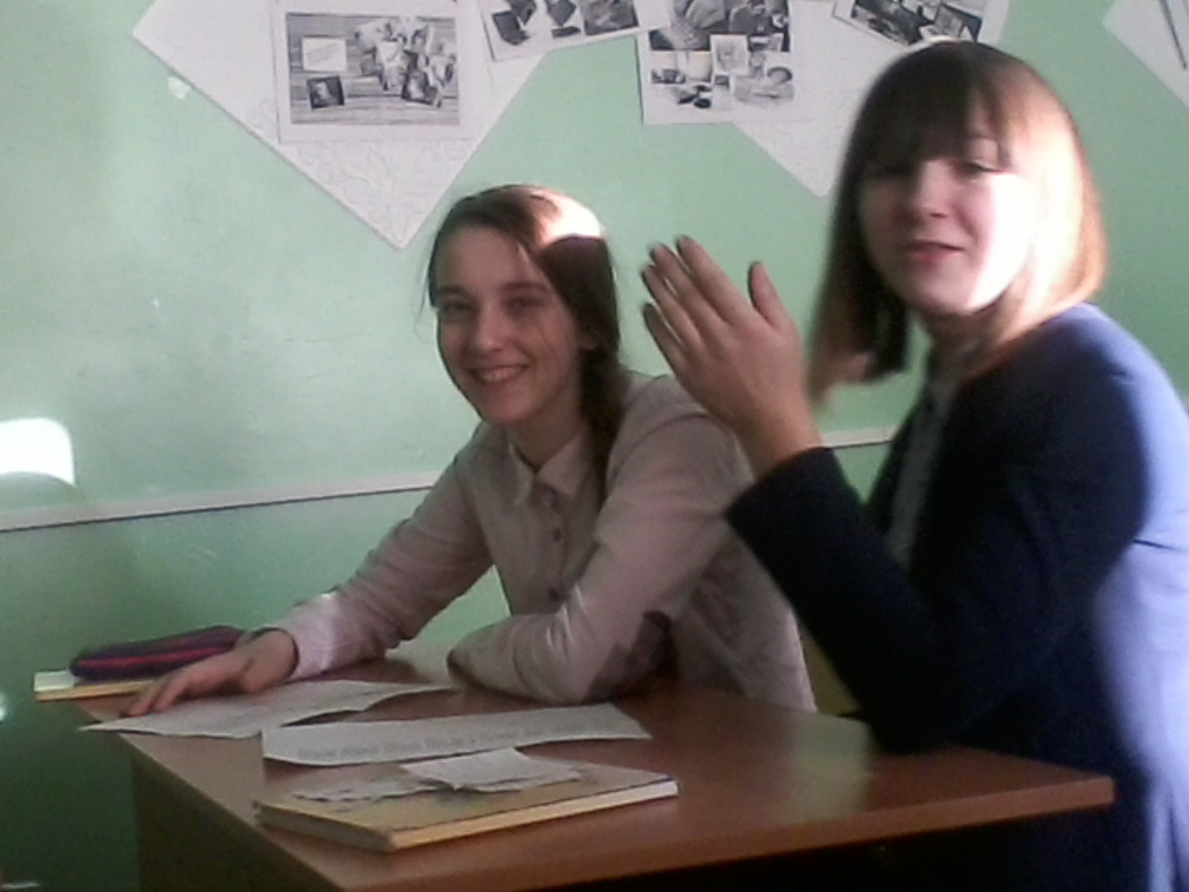
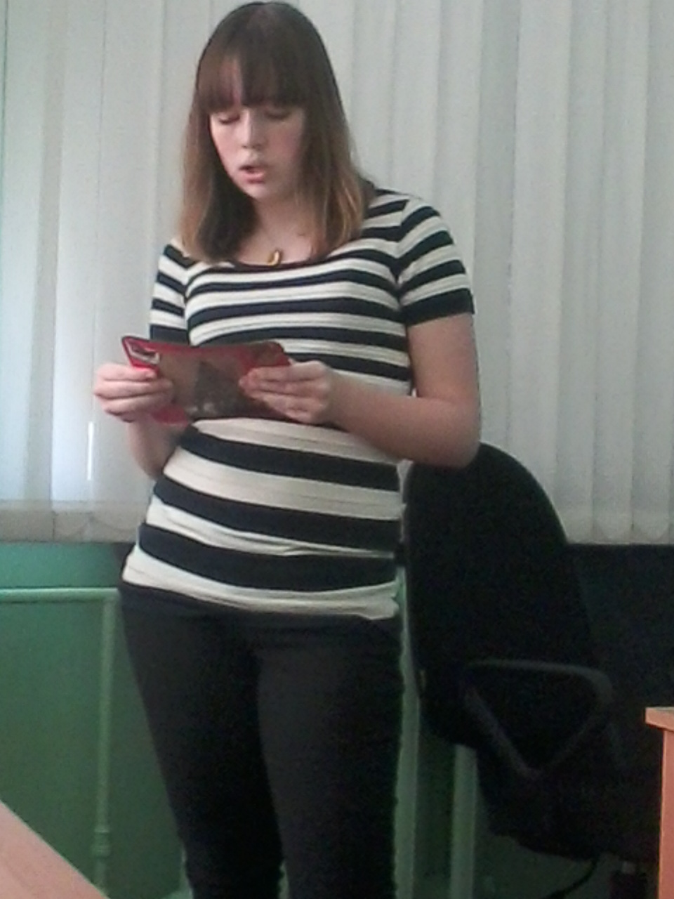
Щербакова Анастасия
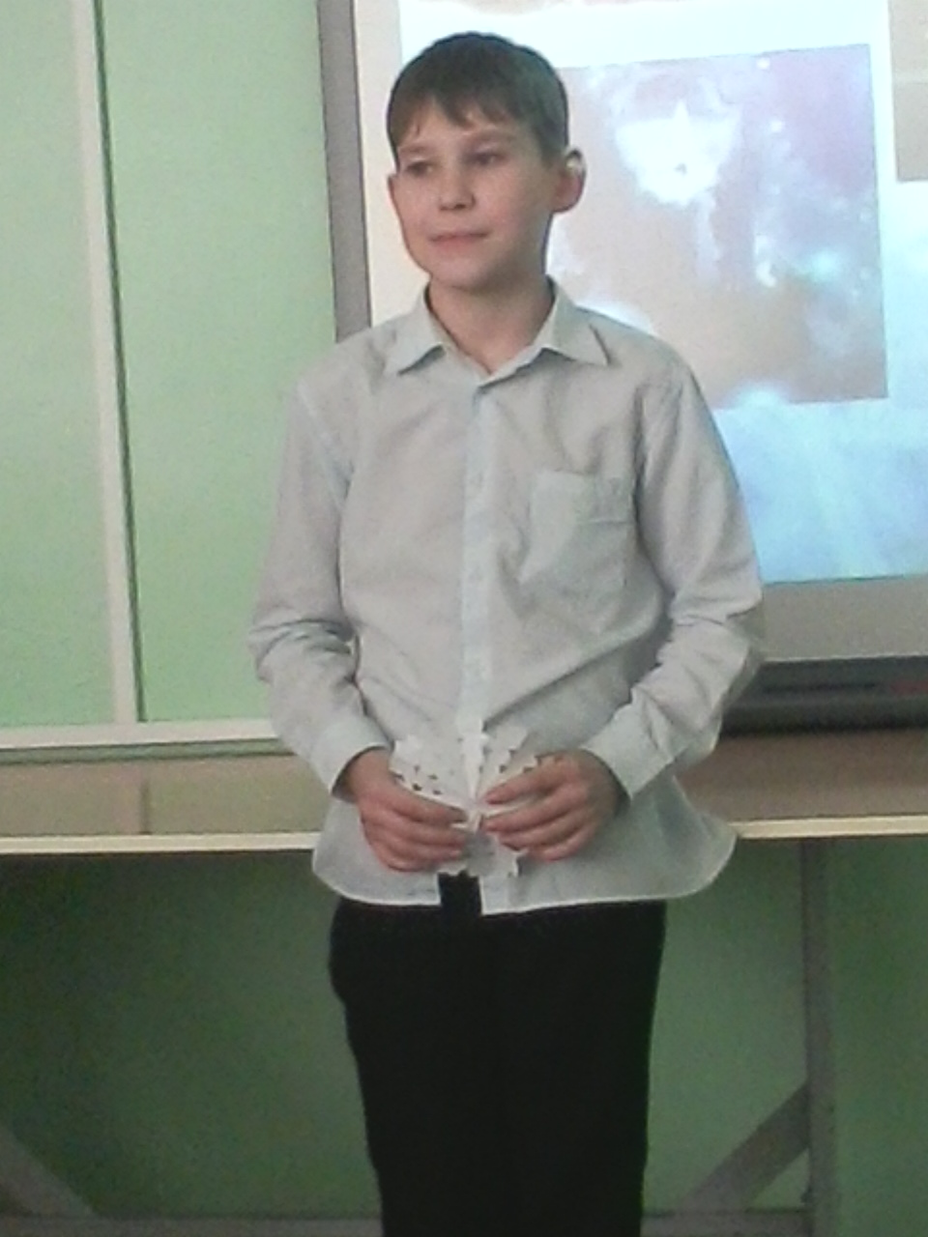
Мацнев Дмитрий

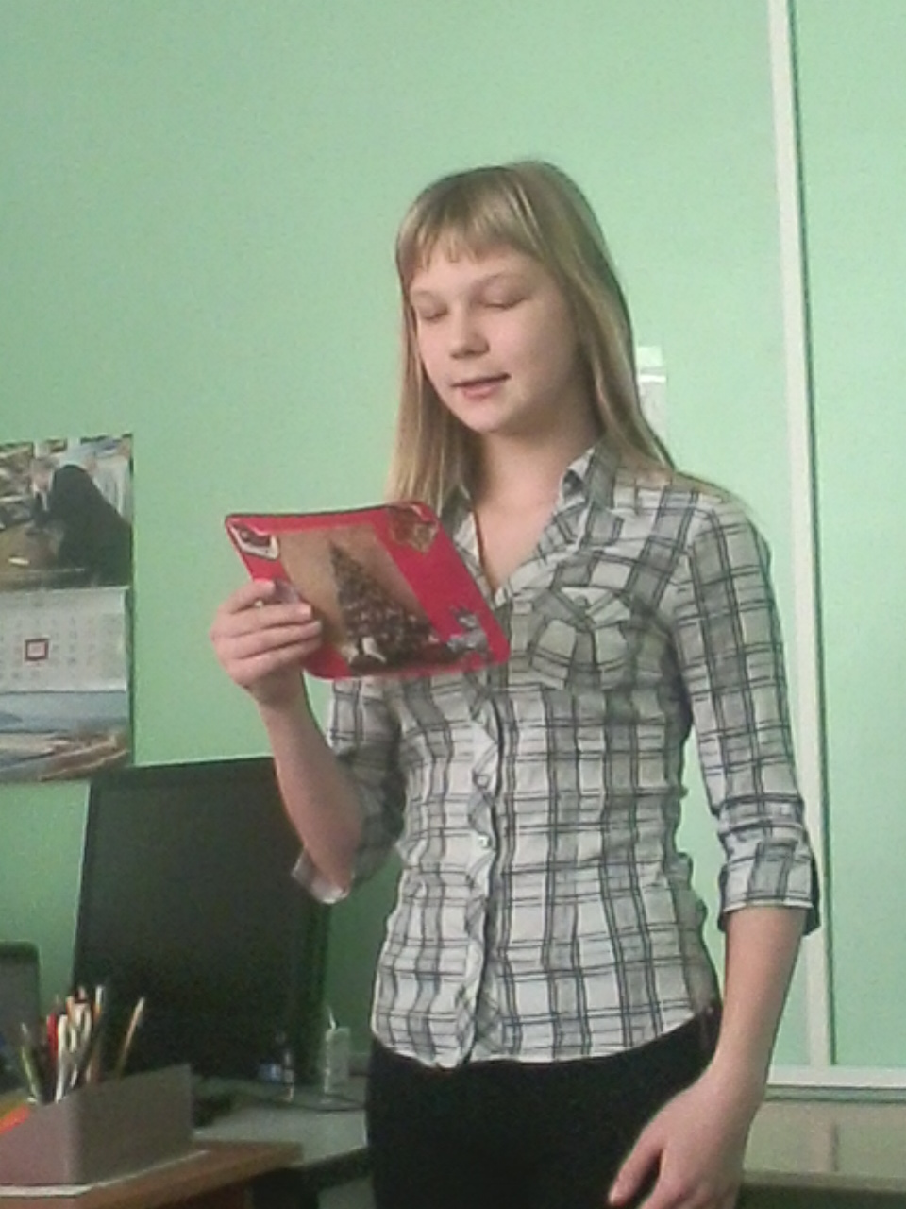
Цыбулина Ирина
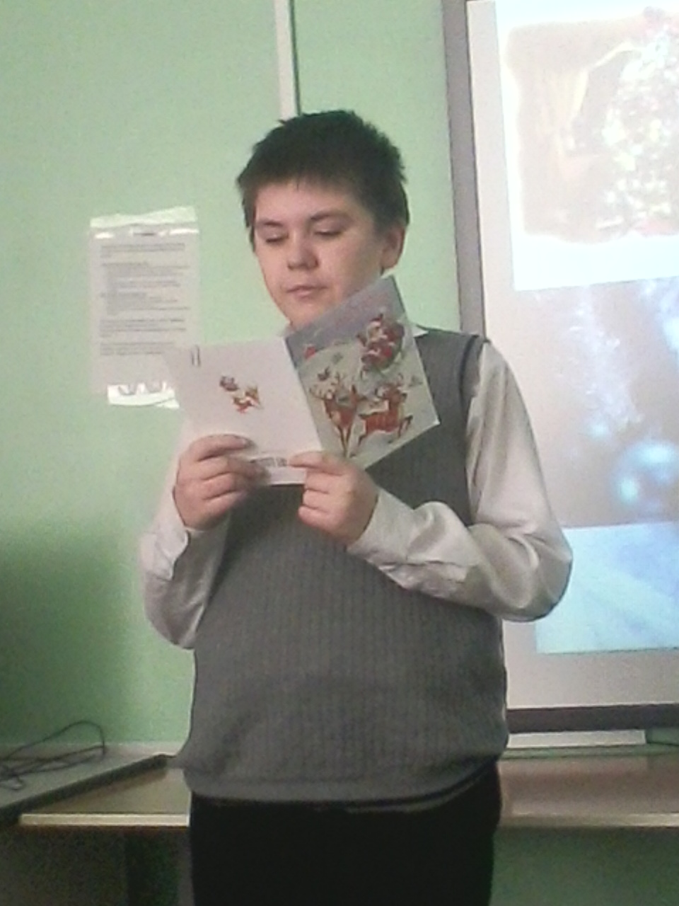
Тютюник Вячеслав
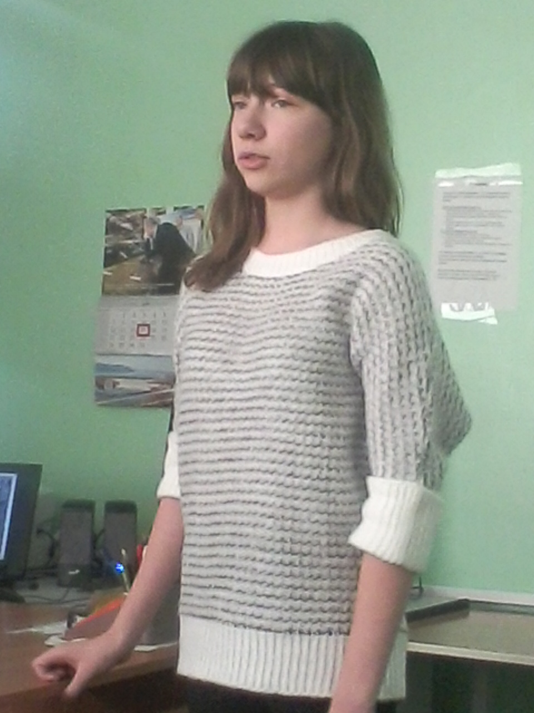
Ромашова Виктория
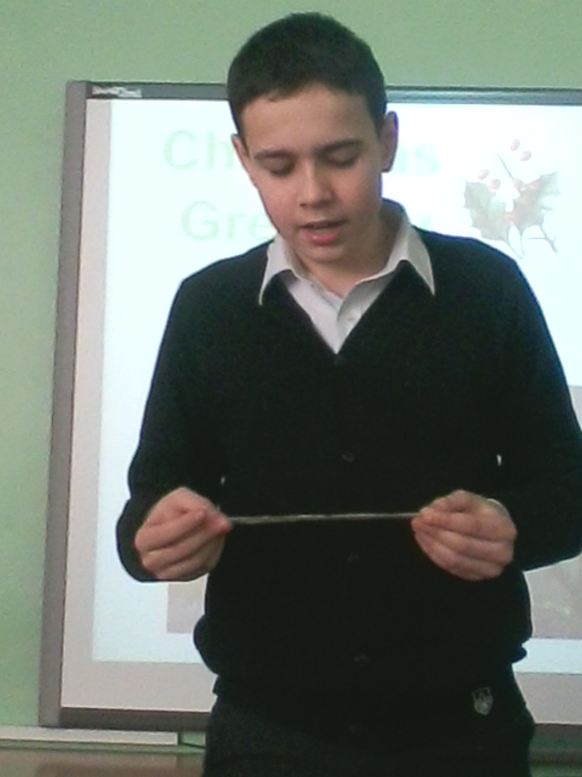
Нуйкин Максим
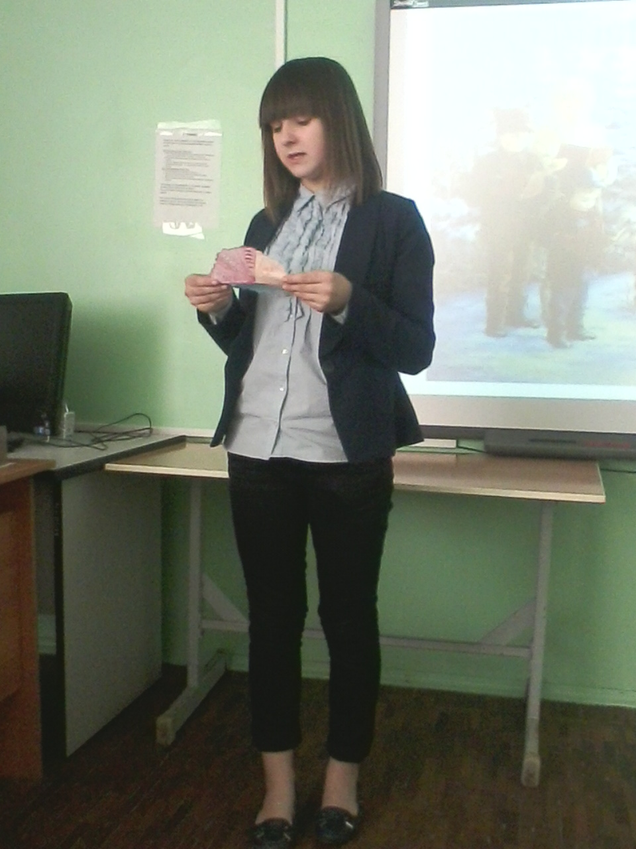
Шамрицкая Лоя
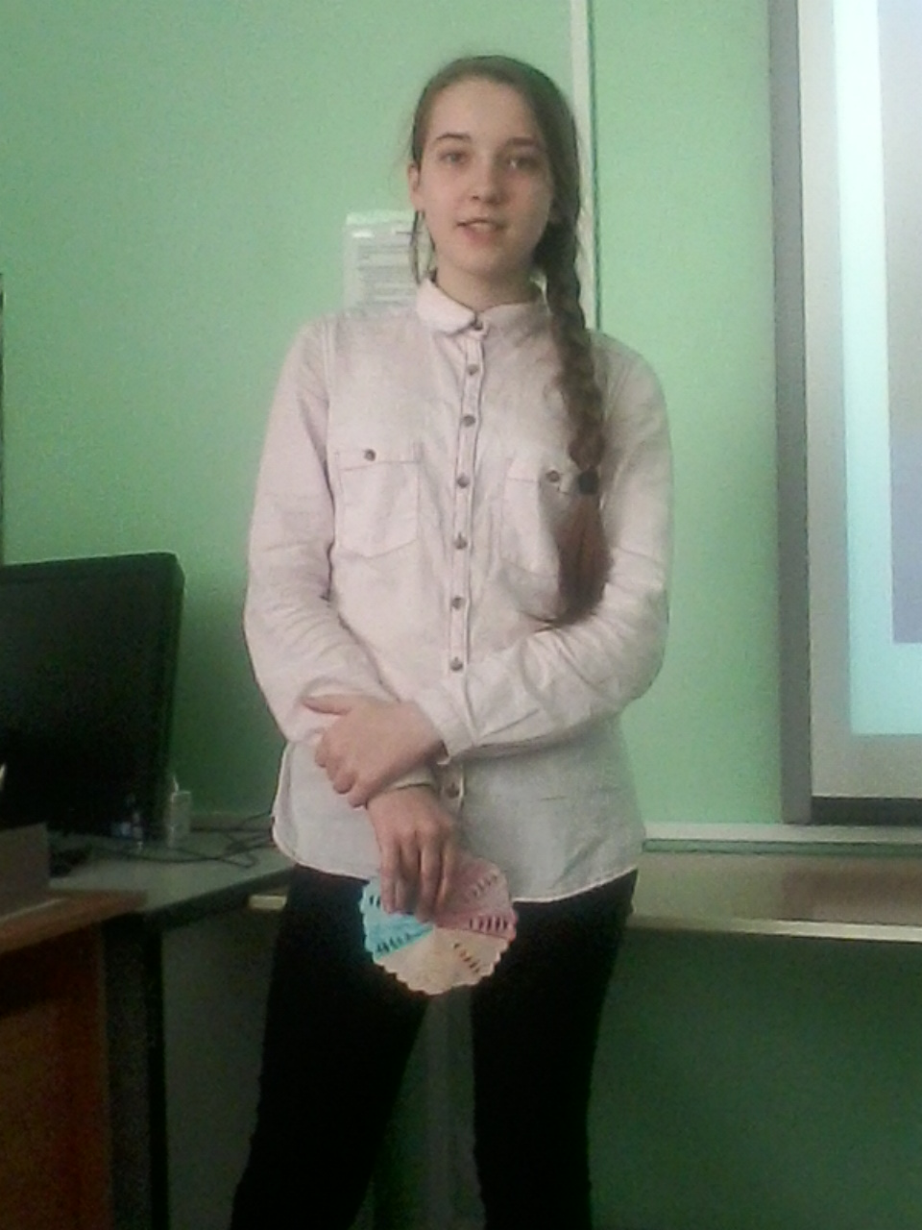
Лаврушина Алена

Кормаков Алексей
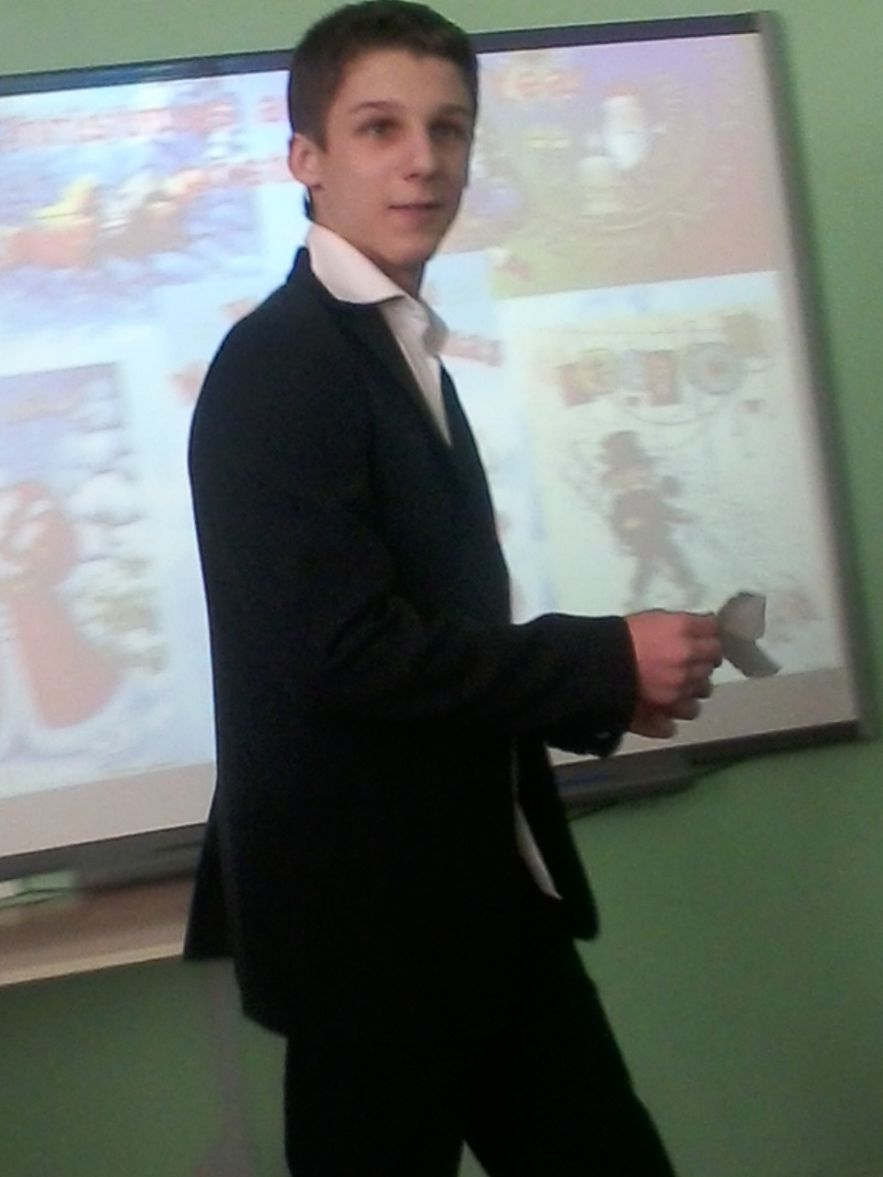
Святкин Данила

