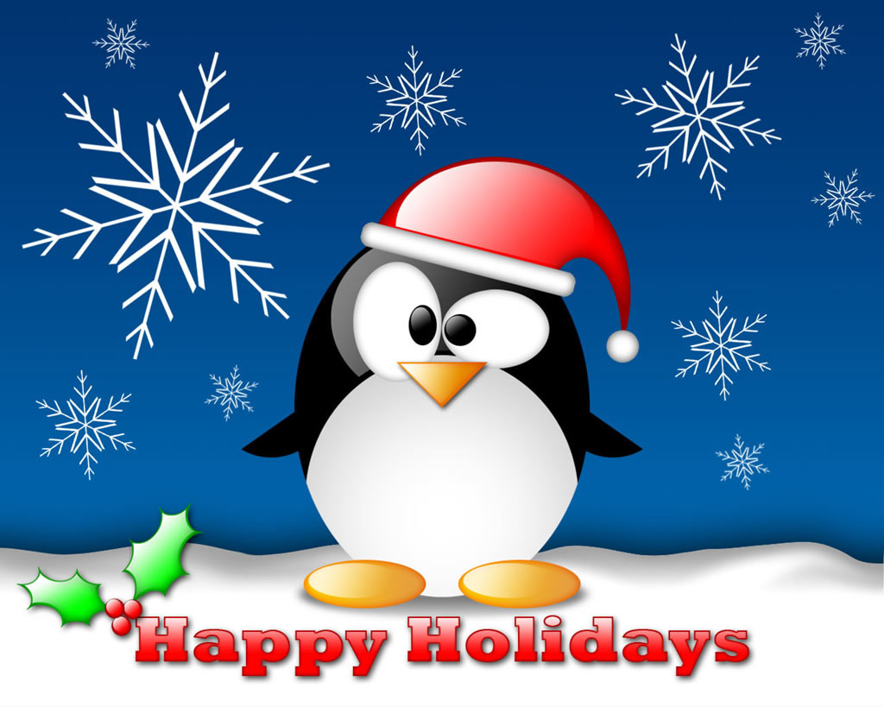
1.Guess these scramble Christmas words
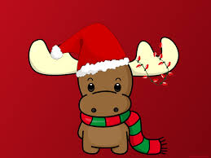
rebmeceD
erte
ehlgis
namwosn
yoialhd
ssatihCrm
atSna

2. 
Santa Claus sent us a secret telegram. And those of you who knows English alphabet very well guess it quickly.
4.15.14.20 | 6.15.18.7.5.20 | 20.15 | 12.5.1.22.5 | 1 | 16.12.1.20.5 | 15.6
3.15.15.11.9.5.19 | 6.15.18 10.1.14.20.1

3

Christmas Find the Differences Game
Try to find the eight differences between these two Santa Claus images.
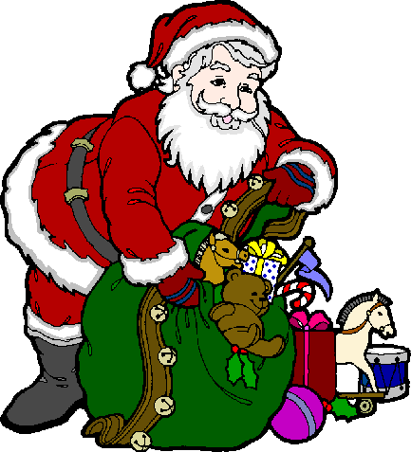

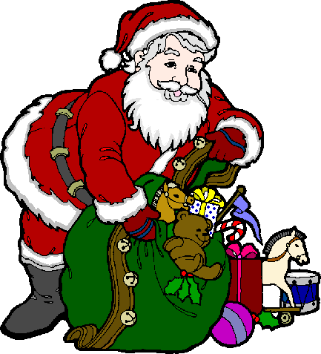

4
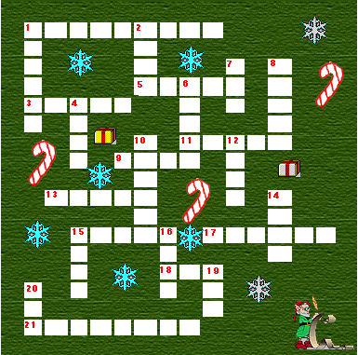

DOWN  1 A Place  2 Santa brings ____  4 A Christmas Carol  6 Silent ___  7 Baked ___  8 ___ O Saint Nick  10 Go on the tree  12 A feeling  14 Let it ____  15 "Candy____"  16 Christmas ___  19 Santa's helper  20 ___ & green | ACROSS  1 "Merry _____"  3 Cookies & ___  5 ___ Clause  9 A ___ for you.  11 A green plant  13 The ___ of Christ  15 His birthday  17 What Santa says  18 Night before  21 This month
WORDS - CANDY - CANE - CHRIST - CHRISTMAS - CHURCH - DECEMBER - ELF - EVE - GIFT - HAM - HO HO HO - HOLLY - JOLLY - LIGHTS - LOVE - NIGHT - NOEL - RED - SANTA - SNOW - TOYS - TREE

5

Santa Quiz
Select the correct answer for each question.
Начало формы
1. | Where does Santa live?  Florida  Antartica  North Pole
2. | How many reindeer pull Santa's sleigh on a foggy night?  8  9  12
3. | Is Santa married?  Yes  No | 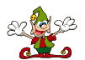
4. | What is Santa's favourite treat on Christmas Eve?  Pizza  Tacos  Cookies and milk
5. | Which of these is not the name of one of Santa's reindeer?  Rudolph  Dasher  Merry
6. | Who helps Santa get ready for Christmas?  Reindeer  Elves  Penquins | 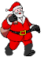
7. | Does Frosty the Snowman live at the North Pole with Santa?  Yes  No
8. | How many times does Santa check his list to see if you have been naughty or nice?  Once  Twice  Four times
9. | What colour boots does Santa wear?  Red  Brown  Black | 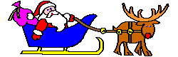
10. | Does Santa wear glasses?  Yes  No

